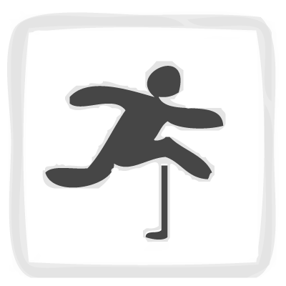

**Event Type: Track, Sprinting**

**Heptathlon Best: 12.54 secs, Jessica Ennis (GB)**

For the 100 m hurdles the first hurdle is placed after a run-up of 13 metres from the starting line. The next 9 hurdles are set at a distance of 8.5 metres from each other, and the home stretch from the last hurdle to the finish line is 10.5 metres long.

The hurdles are designed to fall if bumped into, but this will then have an effect on the time of the athlete.

As a sprint event the athletes use “starting blocks” for a fast take-off.

**100m Hurdles**

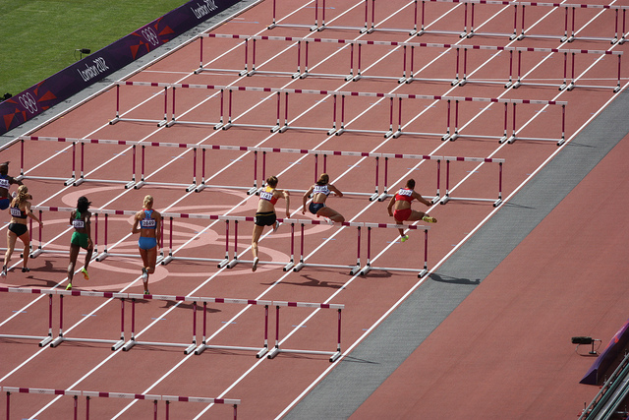



**Event Type: Field, Jumping**

**Heptathlon Best: 7.27m, Jackie Joyner Kersee (USA)**

Athletes combine speed, strength, agility, and technique to propel themselves as far as possible from the take-off board.

A sand-pit is used to allow for a softer landing and to provide an accurate means of measuring the jump.

The long jump is measured from the board to the nearest mark in the sand that is made by the athlete during the jump.

An official is placed alongside the take-off board to determine is a foul has occurred if the athlete breaks the line of foul-line. There is often a thin strip of plasticine at the end of the jump board to show a mark clearly is a foul has occurred.

**Long Jump**

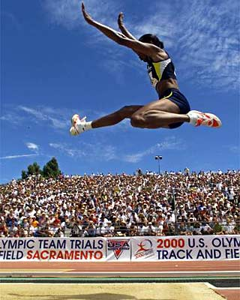



**Event Type: Field, Throwing**

**Heptathlon Best: 17.31m, Austra Skujytė (LTU)**

Although the Shot Put is classified as a throwing event the motion of the throwing action is strictly monitored. The action is more of a pushing technique, where a heavy metal ball (the shot) is projected as far as possible.

The throw must take place within the marked circle, if an athlete steps over the circle the throw is a foul and will not be measured.

The shot is usually rested on the next prior to the throw and the action is that of pushing the arm away from the body to propel the ball into the distance.

**Shot Put**

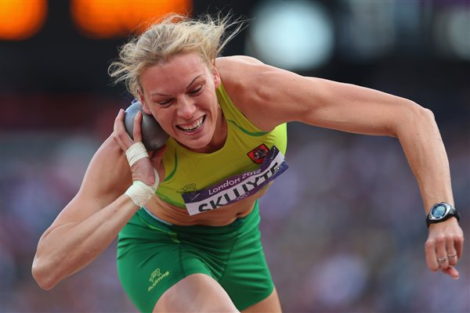

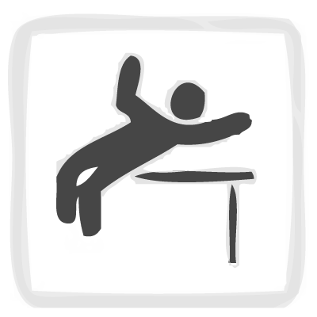

**Event Type: Field, Jumping**

**Heptathlon Best: 1.97m, Tia Hellebaut (BEL)**

In the high jump the athlete aims to leap over a horizontal bar. Each time a height is cleared the bar will be raised to a new height where an athlete will have three attempts to clear it.

The jumper must take off from one foot. The bar is balanced at it’s height and if it is dislodged and falls the jump is fouled.

The most common jumping technique is the “Fosbury Flop” where a jumper aims to go over the bar shoulders first and land on their back on a padded mat.

**High Jump**

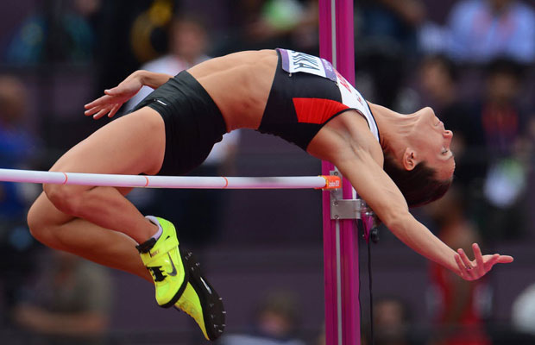

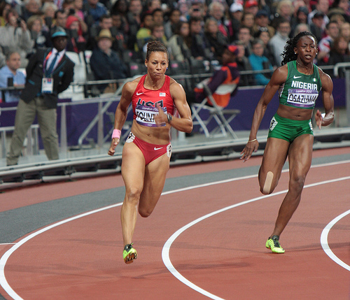

**Event Type: Track, Sprinting**

**Heptathlon Best: 22.30 secs, Jackie Joyner Kersee (USA)**

The 200 metres is a sprint race. The race starts on the final curved bend of the track and finishes down the “home-straight” to the finish line.

The 200m is a mixture of sprint and endurance where the high tempo speed needs to be kept going for a longer distance.

Because of the curve of the track the athletes have a staggered start to make sure that all athletes run the same distance to ensure for a fair race.

**200m**



**Event Type: Field, Throwing**

**Heptathlon Best: 56.96m, Sofia Ifadidou (GRE)**

The Javelin is a “spear” that is thrown the greatest distance possible.

The throwing action has strict guideline. The Javelin must be held at the grip, and thrown over-arm with the spear travelling over the athletes shoulder.

The athlete can build up momentum along a runway, but must throw the javelin before the foul-line. They must not step in front of the foul line at any point.

The Javelins had to be redesigned in the 80’s to limit the possible distances because the potential dangers of the projectile.

**Javelin**

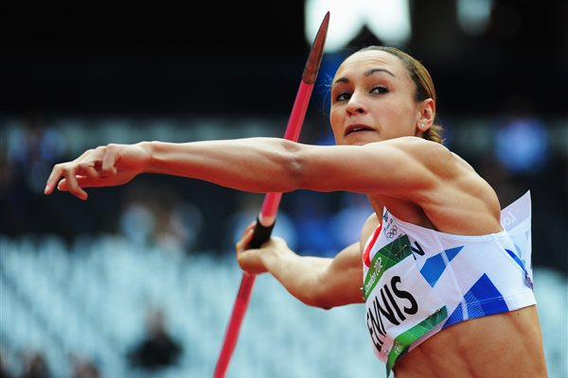

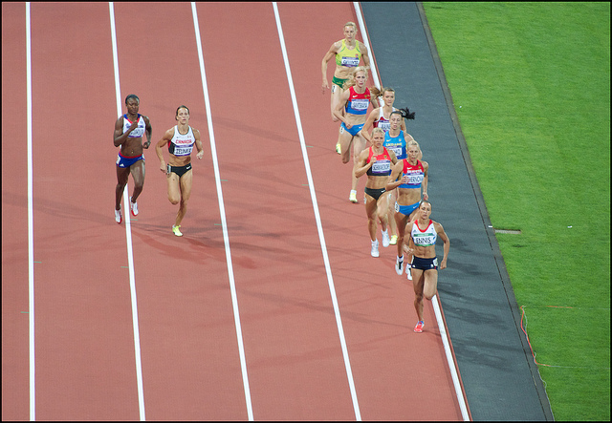

**Event Type: Track, Middle Distance**

**Heptathlon Best: 2:01.84, Nadine Debois (FRA)**

The 800 metres is 2 laps of an athletics track and roughly equates to half a mile.

It is a run that combines endurance, speed and tactics as the athletes aim to get best track position for the final sprint.

**800m**