NERVE PHYSIOLOGY

Introduction

This program simulates a number of experiments which can be conducted on the frog sciatic nerve to investigate some of the important characteristics of compound nerve action potentials (CNAP) recorded from mixed nerves.

High resolution simulations of CNAP's are presented in a form comparable to that of a storage oscilloscope and students take measurements directly from the monitor in much the same way as they would if they were performing the experiment for real. The simulated CNAP's are all derived from actual experimental data.

Conducting an Experiment and Taking Measurements

In each experiment there is a variable which is controlled by several buttons. Thus for the stimulus strength-response experiment pressing each of the buttons selects a different stimulus voltage e.g. 1.75 V. Similarly in the experiment to investigate the action of procaine the buttons select a time at which you can view the CNAP after the initial application of procaine e.g. one button allows you to view the response 120 s after procaine was applied to the nerve.

In each experiment selecting a variable (e.g. stimulus voltage, stimulus separation) will produce an appropriate response on the screen which will persist and from which measurements may be taken. If another function key is pressed a second response will appear on the screen i.e. be superimposed on the first. If you wish to view single responses there is a CLEAR facility which will clear the graticuled screen.

In most of the experiments you are required to measure either the amplitude or latency of the CNAP. Simulated compound action potentials are presented on a graticuled screen display (see below). The vertical (voltage) and horizontal (time) scales are shown in the boxes to the left of the graticuled screen. Thus, as shown below, the action potential has an amplitude of 3 divisions. Since each division on the vertical voltage scale represents 250 mV, the amplitude is 3 x 250 mV = 750 mV. Similarly the duration of the action potential is 3.4 x 0.4 ms = 1.36 ms. Remember also that the displayed responses have been amplified. Therefore the amplifier gain, which in this experiment was fixed at x1000, should be taken into account when calculating the amplitude of the action potential.

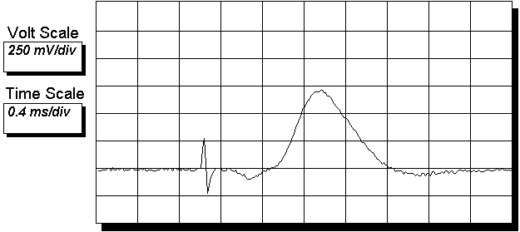

Beware when superimposing responses that for example two different stimulus voltages do not give the same response e.g. the two greatest stimuli in the stimulus strength-response experiment.

TUTORS' NOTES

The following information is intended to assist teachers to use the program most effectively. Inevitably some knowledge of nerve physiology is assumed.

1. The preparation

The description of the frog sciatic nerve preparation raises a number of interesting points which could be further developed in class e.g. the concept of spinal nerves and dermatomes; myelination and its importance in conduction velocity; sensory and motor components of a mixed nerve; threshold of excitation and the 'all-or-nothing' law. Point out that the frog is dead (pithed) when the nerve is removed and that the preparation essentially consists of a large bundle of axons with little capacity to generate ATP and actively exchange Na⁺ and K⁺ ions. It can however still generate thousands of action potentials.

2. Experimental Apparatus

Recording is achieved by simply laying the nerve across metal pin electrodes. Stress it is NOT intracellular recording nor does the action potential represent that recorded from a single axon. Possibly introduce ideas of microelectrode recording techniques and patch clamping.

Action potentials are generated in individual fibres of the bundle by passing current from two stimulating electrodes, in contact with the nerve, through the membranes of these fibres. This stimulating current depolarises the fibres and generates action potentials which are conducted away from the stimulating electrodes in both directions. The resulting compound or mass action potential is recorded as it passes the recording electrodes and is biphasic in nature.

Electrical stimulation also produces a surface current which is conducted along the moist surface of the nerve producing a large p.d. as it passes the recording electrodes. This would mask the action potential as it will arrive shortly before it and because of its large amplitude. It is therefore removed by an earth electrode positioned between the stimulating and recording electrodes which has no effect on the action potential - explain why.

The stimulus artefact arises because the earth is not totally effective but due to its rapid conduction it does serve as a useful marker of the point of stimulation. The time from the beginning of this artefact to the start of the action potential is the latency.

It may also be useful to discuss amplification (remember the amplifier used in this experiment had a fixed gain of x1000) and the use of oscilloscopes to record rapid electrical events.

3. Form of the action potential

The compound nerve action potential is biphasic. Stress that this is due to the recording electrodes being of opposite polarity and that it does not represent the depolarisation, repolarisation, hyperpolarisation phases of a single fibre action potential which is typically shown in textbooks. This can be shown by reversing the polarity of the electrodes in which case the recorded action potential will be inverted, or by destroying the nerve between the two recording electrodes (crush with forceps) in which case the second phase of the action potential will be eliminated and it will become monophasic.

4. Stimulus strength - response experiment

Plotting stimulus voltage against action potential amplitude (mV) produces the following graph.

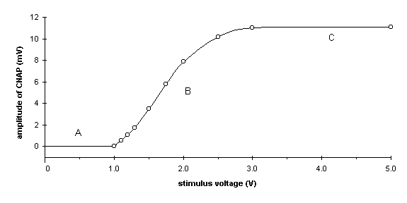

In A the stimulus voltage is sub-threshold (sub-liminal) and too small to generate action potentials in any fibres.

In B more and more fibres are generating action potentials as their thresholds of excitation are exceeded and thus the amplitude of the CNAP increases. This phase often has a 'stepped' appearance due to the fact that bundles of fibres of similar threshold are excited simultaneously.

In C all fibres are now generating action potentials as the stimulus voltage is sufficiently high to exceed the threshold of excitation of all fibres i.e. suprathreshold.

Compare the graded response you get from a mixed nerve to that you would expect from a single axon i.e. 'all-or-nothing'.

5. Refractory Period

The refractory period is the period of inexcitability which immediately follows an action potential. It consists of two phases: an absolute refractory period when the nerve fibre is totally inexcitable and a relative refractory period when it has reduced excitability. Explain the principle of the experiment where two consecutive stimuli are applied to the nerve at varying inter-pulse intervals. Thus if the second stimulus is applied during the absolute refractory period of some fibres these will not fire and the second CNAP will be reduced. By gradually reducing the stimulus interval and measuring the amplitude of the second CNAP (H2) relative to the first (H1) it is possible to determine the range of absolute refractory periods of fibres in the sciatic nerve. This is illustrated in the following graph:

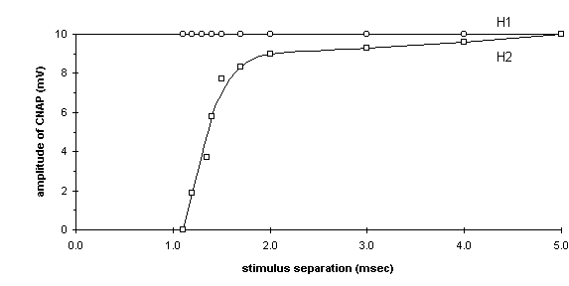

Stress that the stimulus voltage used in this experiment is supramaximal and explain why. Note it is impossible to determine the relative refractory period in this experiment.

6. Conduction Velocity

The conduction velocity is calculated by measuring the latency of the action potential (ms) at a known distance between the stimulating and recording electrodes (mm). The latency is then the time taken for the action potential to travel over that distance and

conduction velocity (mm/ms) = distance (mm)
time (ms)

In effect this measurement gives the conduction velocity of the fastest conducting fibres in the sciatic nerve since the CNAP can be envisaged as a normal distribution of different fibres with varying conduction velocities. If the time to the end of the CNAP is measured and the velocity calculated as above then the conduction velocity of the slowest conducting fibres can be determined. Similarly if the time to the peak of the CNAP is measured a mean conduction velocity for the sciatic nerve as a whole can be determined.

Students should understand the importance of taking a number of measurements of latency. In practice the distance between the stimulating and recording electrodes is altered by moving the latter electrodes (the stimulating electrodes should not be moved to ensure that the stimulus is constant). If latencies are measured at a number of different distances then a mean can be calculated and the velocity determined more accurately.

Distance (mm) | Latency (ms) | Conduction velocity (mm/ms)
24 | 0.84 | 28.6
20 | 0.74 | 27.0
16 | 0.54 | 29.6
12 | 0.52 | 23.1
8 | 0.24 | 33.3

Mean conduction velocity = 28.3 ± 3.7 (SD) mm/ms

Explain that conduction velocities of nerves are usually expressed in m/s. Compare the conduction velocity of the frog sciatic nerve with that of mammals. Discuss factors affecting conduction velocity
e.g. myelination, axonal diameter (classification of nerve fibres according to size) and temperature.

7. Effect of Temperature

One important factor which affects conduction velocity is temperature. Cooling the nerve by dripping on ice-cold Ringers solution markedly reduces conduction velocity. This should be related to the rate of chemical reactions being slowed and discussed relative to the frog's response to a decrease in temperature of the environment.

8. Action of Procaine

Procaine is a lipid soluble local anaesthetic (membrane stabilizer) which dissolves in the membrane and prevents permeability changes occurring when the nerve is stimulated. Introduce ideas of membrane structure and the concept of membrane ion channels which are opened on stimulation (voltage activated).

Procaine has two main effects on the CNAP: (i) the amplitude is reduced as some fibres no longer generate action potentials and (ii) the mean conduction velocity is reduced suggesting that the larger fast-conducting fibres are affected first. This may be because these fibres are nearer the periphery of the bundle and exposed to procaine first - remember it is simply dripped on to the nerve.

PROPERTIES OF NERVE

The physiological properties of nerve can be investigated using the sciatic nerve preparation of the frog. The sciatic nerve consists of two to three spinal nerves, each of which is closely identifiable as a separate bundle. Different nerve cells within the sciatic innervate muscles of the lower limb and have their cell bodies in the spinal cord. These cells will have different characteristics e.g.

- diameter
- threshold of excitation
- conduction velocity
- degree of myelination

SCIATIC NERVE PREPARATION

In order to successfully investigate the properties of the sciatic nerve it is important to obtain as long a stretch of uninjured nerve as possible. The procedure to remove the nerve is relatively straightforward and is summarised below:

1. The frog is stunned and pithed, a procedure which destroys the brain and spinal cord.

2. A circular cut is made with scissors around the belly and the skin covering the lower half of the body removed (removing the "trousers").

3. The frog is laid dorsal surface uppermost and the urostyle removed by cutting through the muscle on both sides and finally cutting it away from the spinal column. At this point the sciatic nerve roots can be seen leaving the spinal cord on both sides. The nerve is ligatured close to where it leaves the spinal cord and cut anterior to the ligature. (Note: the cell bodies which lie in the spinal cord are thus removed.)

4. The nerve is carefully dissected free from surrounding tissue down to the knee joint. The path of the nerve through the thigh may be exposed by parting the muscles of the thigh using the thumbnails. Care must be taken not to touch the nerve with metal dissection instruments or to stretch the nerve unduly. Remember the functioning of the nerve depends on the integrity of the membrane. The nerve must be kept moist throughout with frog Ringer solution which closely resembles the extracellular fluid of the frog.

5. A ligature is tied around the nerve at the knee end and the preparation is placed in a small beaker of frog Ringer solution.

THE NERVE BATH

The nerve bath consists of a perspex, lidded box with inserts for five electrodes. The electrodes are plastic coated wire enclosed in perspex tubing and can be moved relative to each other.

Two of the electrodes are used for stimulating the preparation and must be connected to the two leads from the stimulator. Ensure that the negative lead is the inner lead.

The two other electrodes serve to record the activity of the nerve and should be connected to the input leads of the amplifier.

The last electrode serves as an earth, and is connected to the green earth lead. This electrode must be placed between stimulating and recording electrodes and serves to prevent much of the stimulating current being picked up by the recording electrodes.

The electrodes are positioned as shown below. The sciatic nerve is laid carefully across the five electrodes and a little frog Ringer solution poured into the bottom of the bath (note the nerve should not be immersed). At room temperature, with the lid in place, this ensures that a humid atmosphere is maintained within the organ bath.

isolated
stimulator

AC
amplifier

+
S1
-
R1
+

storage
oscilloscope
-

Sciatic Nerve
Earth

Trigger Lead

Q1 Explain the function of the 'trigger lead' on the diagrammatic representation of the apparatus used to record the compound nerve action potential.

Experiment A - The Form of the Action Potential

Aim: to demonstrate the difference between a monophasic and a biphasic compound nerve action potential.

Measure the peak-to-peak amplitude of the NAP...............(mV)

Measure the latency of the NAP...............(msec)

Q2 Explain the term compound (mass) nerve action potential (NAP).

Q3 Why is the recording of the compound NAP biphasic?

Q4 Crushing the nerve with forceps between the two recording electrodes results in a monophasic action potential. Explain why.

Experiment B - Stimulus Strength-Response Curve

Aim: to demonstrate the relationship between the stimulus voltage applied to the nerve and the NAP amplitude.

Measure the amplitude of the NAP (mV) evoked by each stimulus voltage.

Stimulus voltage (V) | NAP amplitude (mV)
Q5 Draw a graph of the compound NAP amplitude in mV(y-axis) versus stimulus voltage (x-axis).

Explain the relationship between the stimulus voltage applied and the response.

Show with the aid of a diagram how this relationship would differ if the experiment was conducted on a single nerve fibre.

Experiment C - Refractory Period

Aim: to measure the range of absolute refractory periods of different fibres in the frog sciatic nerve.

Measure the amplitude (mV) of the NAP evoked by the first stimulus of the pair (H1) and that evoked by the second stimulus (H2) at each stimulus separation. It is suggested that you start with a stimulus separation of 5 msec.

Stimulus separation (msec) | H1 amplitude | H2 amplitude

Q6 Draw a graph of Hl and H2 in mV (y-axis) against stimulus interval (separation) in msec (x-axis)

Explain why the amplitude of H1 does not change, and the decrease in and eventual disappearance of H2.

Experiment D - Conduction Velocity

Aim: to measure the fastest and mean conduction velocities of different fibres in the frog sciatic nerve.

Distance  mm | Fastest c. vel. m.sec⁻¹ | Mean c. vel. m.sec⁻¹
Mean

In order to measure the velocity at which the nerve can conduct an action potential you must record the distance (D) between the negative stimulating electrode and the nearest recording electrode in mm. Then for each distance measure the latency of the response (x msec) and the time to the peak of the response (y msec). The distance D must be altered by moving the recording electrode closest to the stimulating electrode. Then

- D/x gives the fastest conduction velocity in mm.msec⁻¹

- D/y gives the mean conduction velocity in mm.msec⁻¹

Express conduction velocities in metres per second.

Q7 How would you expect the measured conduction velocities to compare with those of the frog in its natural environment? Explain your answer.

List the three major factors which affect conduction velocity.

1

2

3

Say how the conduction velocity in the frog sciatic nerve compares to that of mammals. Give reasons.

Experiment E - Effect of Temperature

Aim: to demonstrate the effect of cooling the nerve from room temperature (20°C) to (0°C) on conduction velocity.

Q8 Calculate the change in mean conduction velocity upon application of the ice-cold Ringer.

 | Control | 0°C | Recovery
Mean Conduction Velocity

m.sec⁻¹

Say whether cooling affects all types of fibres, i.e. does the distribution of conduction velocities change?

Experiment F - Action of Procaine

Aim: to demonstrate the action of the local anaesthetic procaine on the NAP.

Procaine had two main effects:

i)

ii)

Q9 Explain how procaine works.

