

1999 Toyota Vitz
Location: JAPAN
You bought this item.
Paid
FOB Price
US$1,087
¥90,000
View Price
Year / Month: 1999
Odometer: 49,000
Displacement: 1.00 c/c
Steering: Right
Transmission: Automatic
Fuel: Petrol
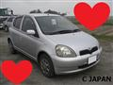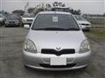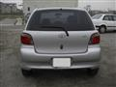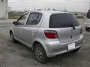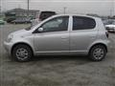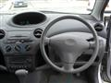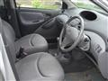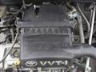
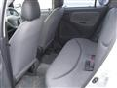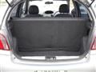

Specific information:
VIN(Vehicle Identification Number)/Serial No. | SCP10-006568
BodyStyle1 | Hatchback
BodyStyle2 | -
Door | 5
Number Of Passengers | 5
Drive Type | -
Exterior Color | Silver
Interior Color | -
Expiry Date | Dec/08/2010(JST)
Condition | Used
Mechanical Problem | -
Options | Anti-Lock Brakes / Driver Airbag / Passenger Airbag / Power Windows / A/C: front / Power Steering / CD Player
Comment | Must see!
Reference No. | 100422112706

